(1) Open the app, click “Upload firmware”, then click “Install Bridge”. Important note: even if you have installed it before, you still need to click “Install Bridge” again to install the required environment.
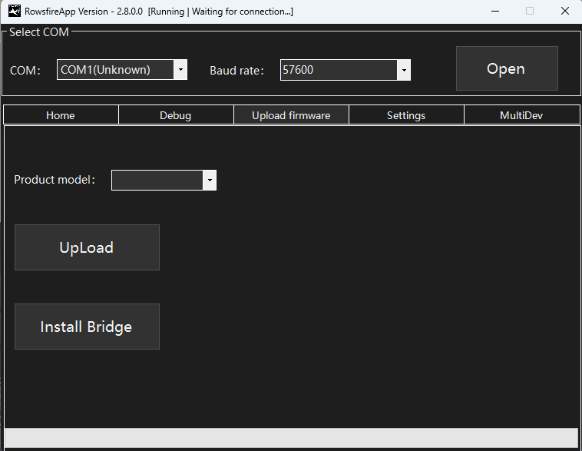
(2) Return to “Home” and click “Panel Control”.
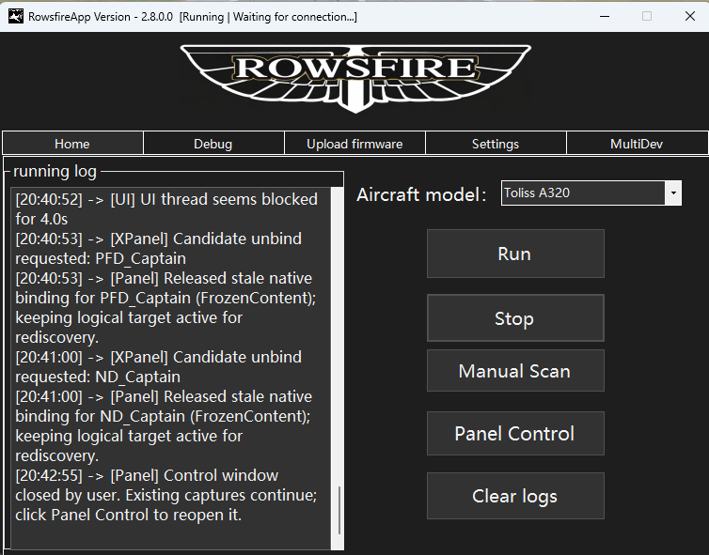
The following screen will appear:
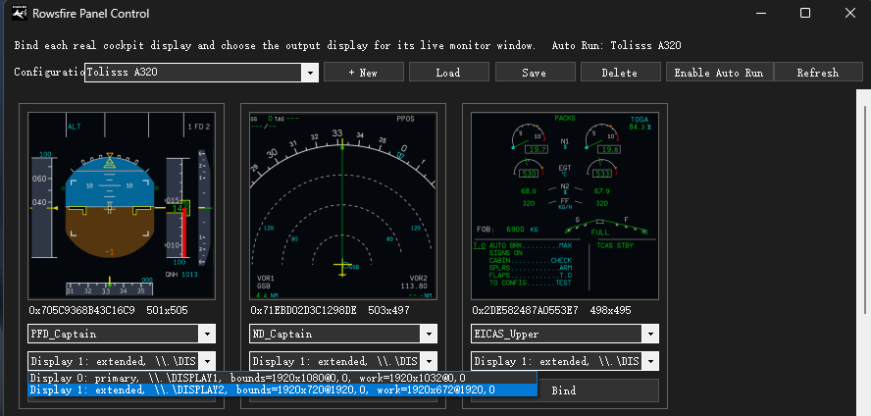
Select the content you want to display, such as PFD or ND. The first drop-down menu is used to select Captain or First Officer; this may vary slightly depending on the aircraft model. Then click “bind” and start the game normally.

Important Notes:
(1) The currently supported aircraft models are as follows:
MSFS: FBW A320, Fenix A320, PMDG 737-600/700/800/900, iFly 737.
X-Plane: Toliss A320, Zibo 737.
(2) Please make sure your system supports DirectX 12.
You can check it as follows:
- Press Win + R.
- Enter:
dxdiag
- Press Enter.
- After it opens, check the first page under System:
DirectX Version
If it shows:
DirectX 12
This means your system supports DirectX 12.

